nImproving your writing skills

Brush up on the basic principles of writing, grammar and spelling.

Read more so you develop an eye for what effective writing looks like.
- Read challenging books, or things you usually read in German in English.

Find a partner. Ask him or her to read your writing and provide feedback.

Take time to analyze writing you admire.
- Find a text you really like, print it out and highlight things you like.
- Look at transitions, phrases etc.

Imitate writers you admire.
- Is he utilizing humor? Pop cultural references?

Outline your writing.
- A sketch of the structure and generic terms

Edit your writing.
- Be your own critic and read out loud

Eliminate unnecessary words from your writing.
- Mistake: complex sentences in attempt to sound competent
- Avoid filler words like: that, just, really etc.

Review your earlier work and see how you’ve advanced.
- Revise old test papers

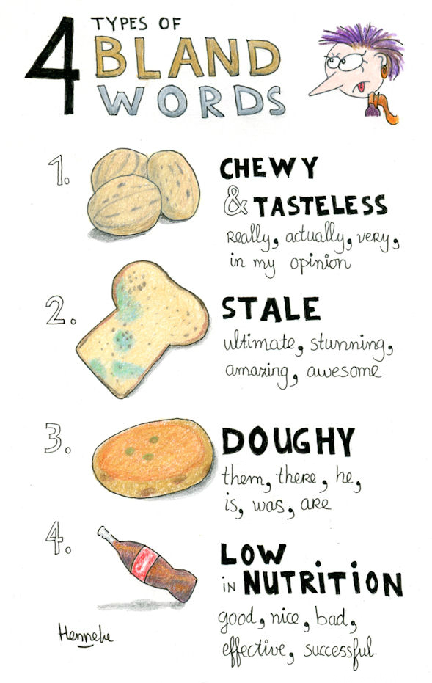
Two Examples:

1: Chewy and tasteless
They slow down your reader without adding meaning.

Example:
In my opinion, this handout is pretty good.

Weak phrases: in my opinion (chewy) and pretty good (low nutritional value)

Tastier:
This handout is entertaining and useful for anyone who writes.
This handout blew my mind. I’ve never seen such a fun tutorial before.

2: Stale

The ultimate guide to developing a good set of writing skills.

Weak word: Ultimate (Stale)

Tastier:
A lazy guy’s guide to developing a good set of writing skills.
A Dilly-Dallier’s Guide to sticking to a good set of writing skills.



